**Computer Lab Skills ~ Easter Copy and Paste**

|  |  |  |  |
| --- | --- | --- | --- |
| egg 4.png | pink jellybean2.png | chocolate bunny.png | grass.png |
| easter basket.png | daisy.png | chick.png | wrapped blue candy.png |

**Name**

|  |  |  |  |
| --- | --- | --- | --- |
| **Easter**  **egg** |  | **grass** |  |
| **flower** |  | **chocolate**  **bunny** |  |
| **jellybean** |  | **basket** |  |
| **chick** |  | **chocolate**  **egg** |  |

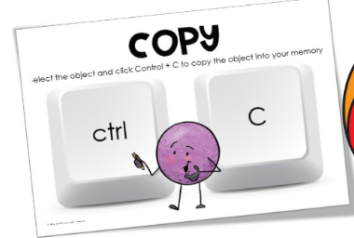 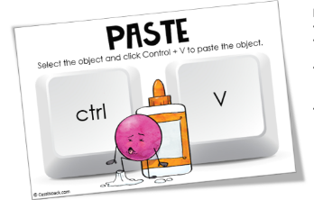

**Type your name, and don’t forget the capital letter. Use shortcuts to copy and paste each picture. Print 1 color copy for Mrs. Gallagher.**